# Portfolio Documentation 2021

**Name:** Yipeng Lin

**Url:** [**https://10re.github.io/csgo_starter_kit_release/**](https://10re.github.io/csgo_starter_kit_release/)

**Repo:** [**https://github.com/10RE/csgo_starter_kit_release/**](https://github.com/10RE/csgo_starter_kit_release/)

**1, Submit a (minimum four page) site. All of the pages must use a common header, footer, and navigation across all pages. Each page must have a unique title**

There are five pages. Index page, weapon page, skin page, accessory page, and about page.

Header:

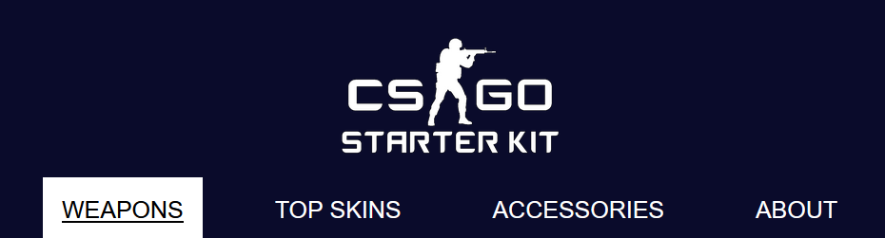

Footer:



**2, The navigation must clearly display the current page within the nav element.**

**As you visit each page, point out how the navigation bar changes to clearly indicate which page you are currently viewing. Don't forget, color alone should never be used to signify important information.**

Current page will be indicated by a reversed colored background, font color, and have an underline, which clearly indicates the current page the user is on.



**3, Each page should contain a main section that can be reached using a Jump to Content option with the first tab on the page. Main must be after the navigation.**

**Make sure to check that "Skip To Content" works on EVERY page.**

Every page has a skip to main content button and it works for all five pages.

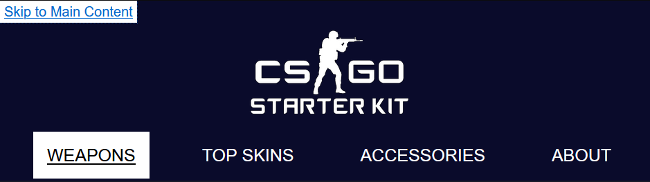

**4, Minimum content present. This includes a page that has at least nine (9) images.**

All pages except the main page have more than 9 images. Take top skins for example:

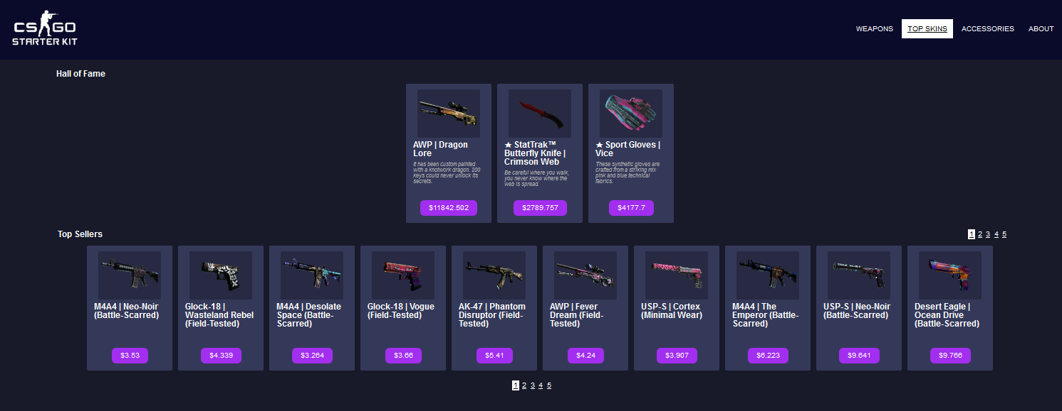

**5, Grid - used more than once, and used effectively.**

**Using the browser of your choice, walk us through the different areas you used grid. Explain how you used them differently than in homework. Show us all of the pages that use them.**

In the desktop view, items are listed in the grid, the column number of the grid will change automatically with the width of the screen.

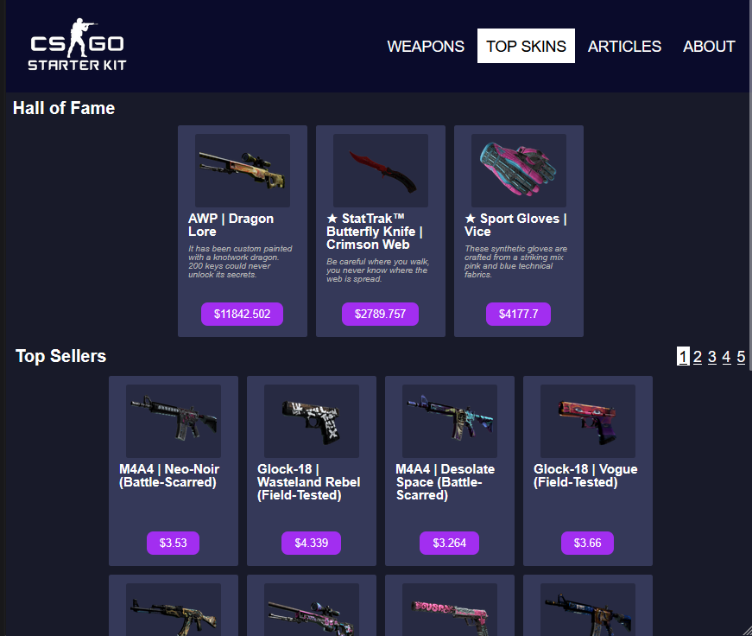

In mobile and tablet view, the item panel is a grid layout, to place the picture, name and description and button in order.

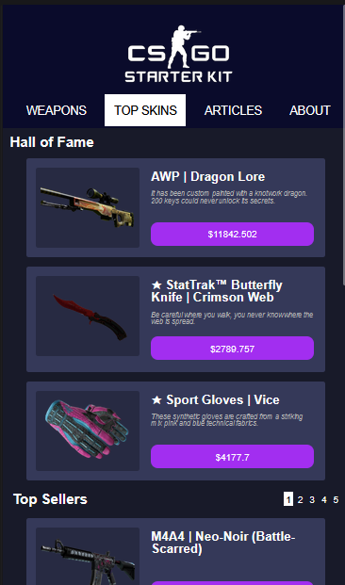

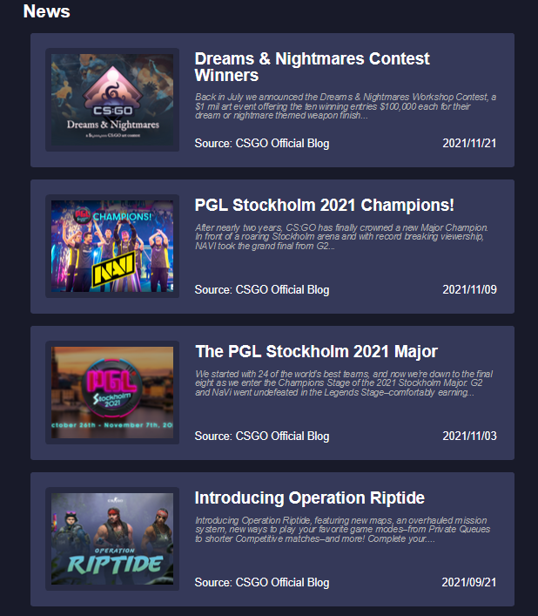

In the desktop view, the about page is a grid. It is used to place text on both sides of the screen for visual appeal.

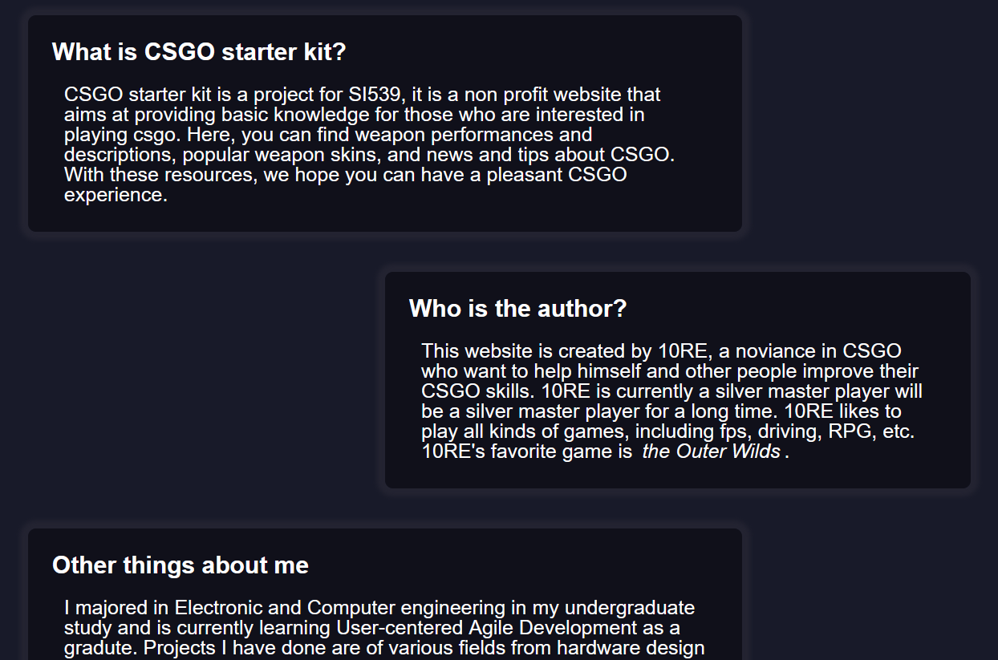

**6, Flex - used more than once, and used effectively.**

**Using the browser of your choice, walk us through the different areas you used flexbox. Explain how you used them differently than in homework. Show us all of the pages that use them.**

In mobile and tablet view, the items are listed as a column flex.



In desktop view, the item panel is a column flex to align the content in order.



The bottom line of the accessory panel is also a flex, to make the source and date be placed at each end of the box.



**7, At least one CSS generated animation that is NOT part of the gallery.**

Skip to content animation.



Flip card animation (from W3C School).

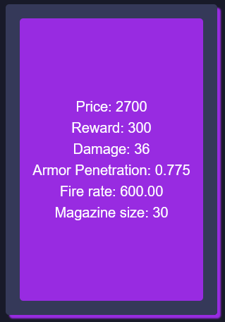

Lightbox animation (from lightbox)

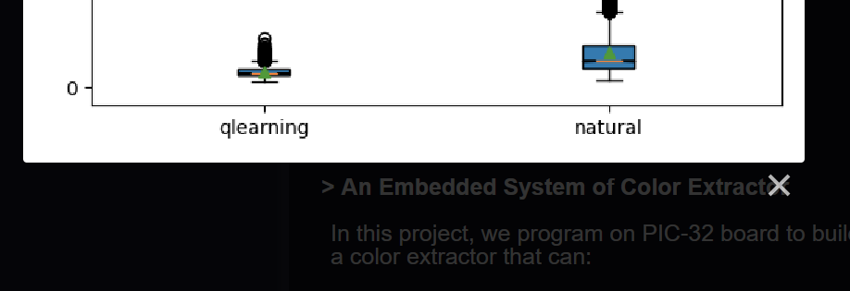

All the animation listed here will be turned off if reduced motion is on.

**8, A working contact form.**

**The form should be processed, not sent via email.**

Using Formspree.

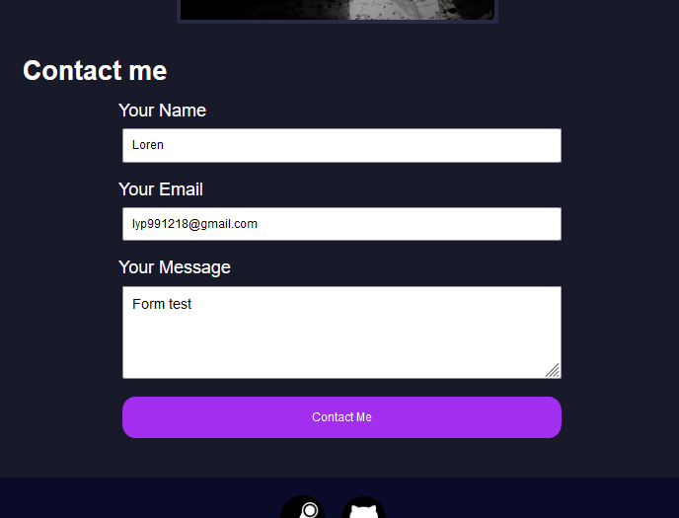

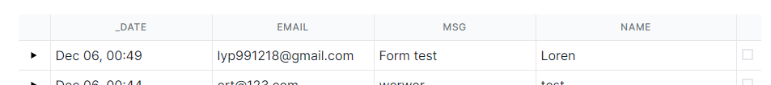

**9, A parallax image**

In the about page for desktop view, the chicken image will be parallax when scrolling.

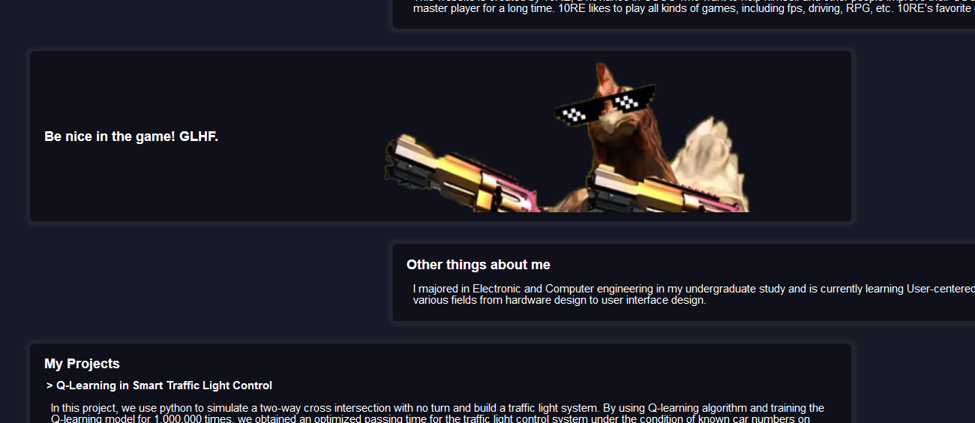

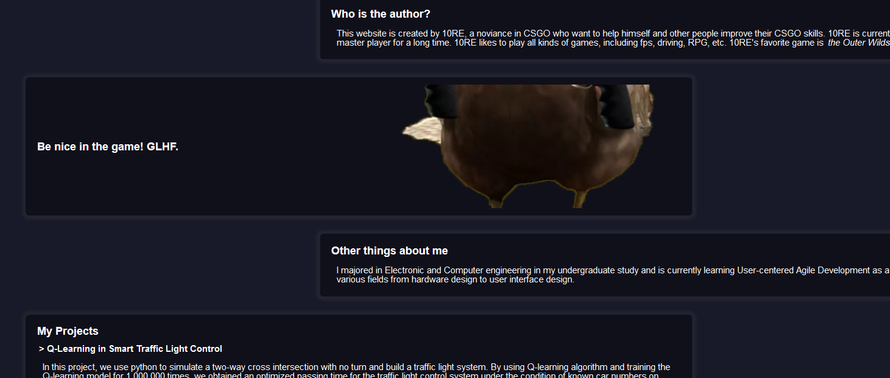

**10, A keyboard accessible flip card using just CSS**

**Demonstrate that the flip card works using a mouse AND the keyboard.**

Panel in the weapon page has a flip card effect. They can also be accessed through tabbing.

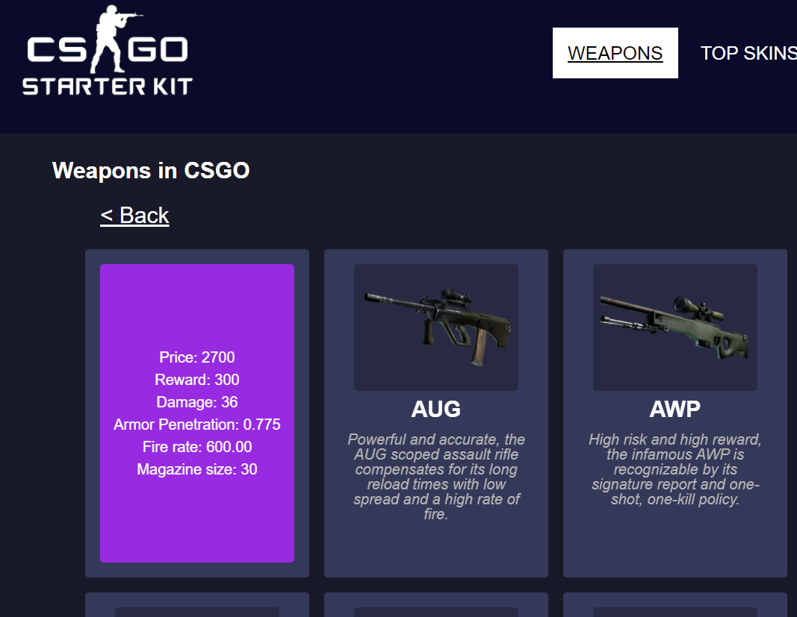

**11, Google Analytics on all four pages.**

**In real time show your Google Analytics dashboard as you enter and leave all four pages of your site. We should be able to see multiple past visitors on each page.**

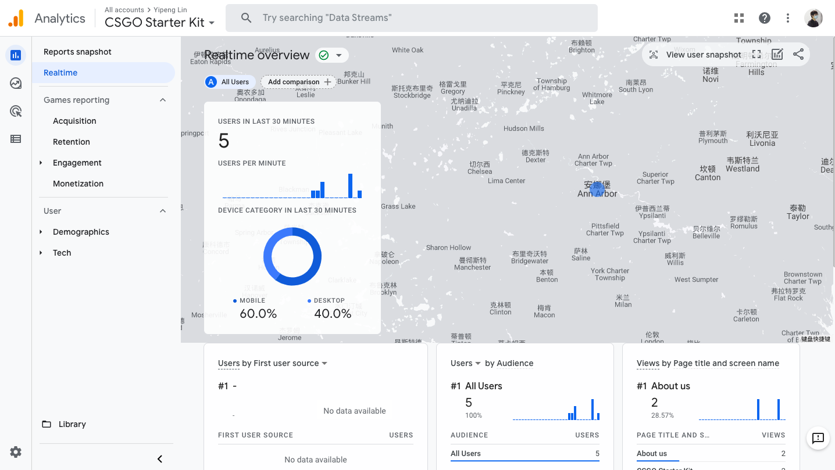

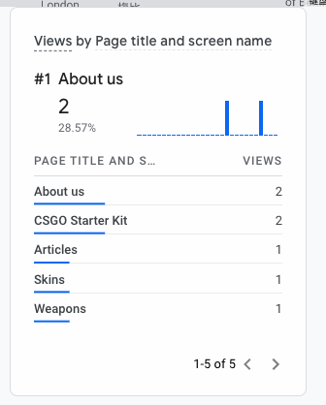

**12, Visually appealing**

**What did you do to make your page particularly appealing? Tell us more about your font choices, image editing, etc. I am sure are things that you did that we can't easily see.**

The pages are of consistent color with analogous color harmony.

The highlighted components, like the selected link, the selected price button, are displayed in reversed color, a white background with black font.



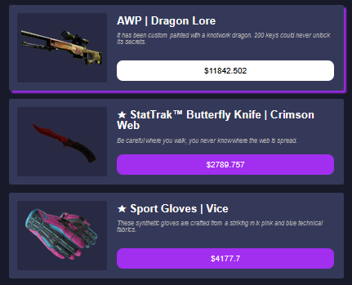

When users hover their mouse on panels, there will be a purple shadow at the back of the panel, simulating a neon light effect. This adds to the technical and future feeling of the website.

This website uses images of high resolution, so users can check the detail of the skin or weapon.

The usage of flip cards makes the page hold more information while maintaining the order and keeping the visual element simple. The flip cards are of consistent style with the hover background color.

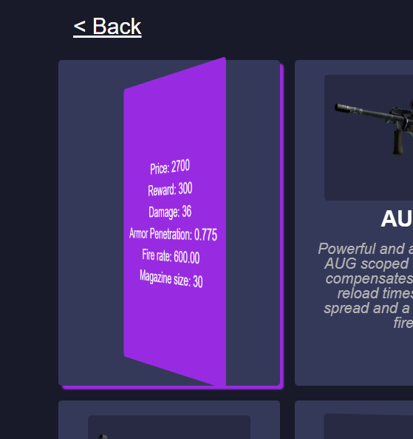

Light box is used in the page for users to view the zoomed in picture.

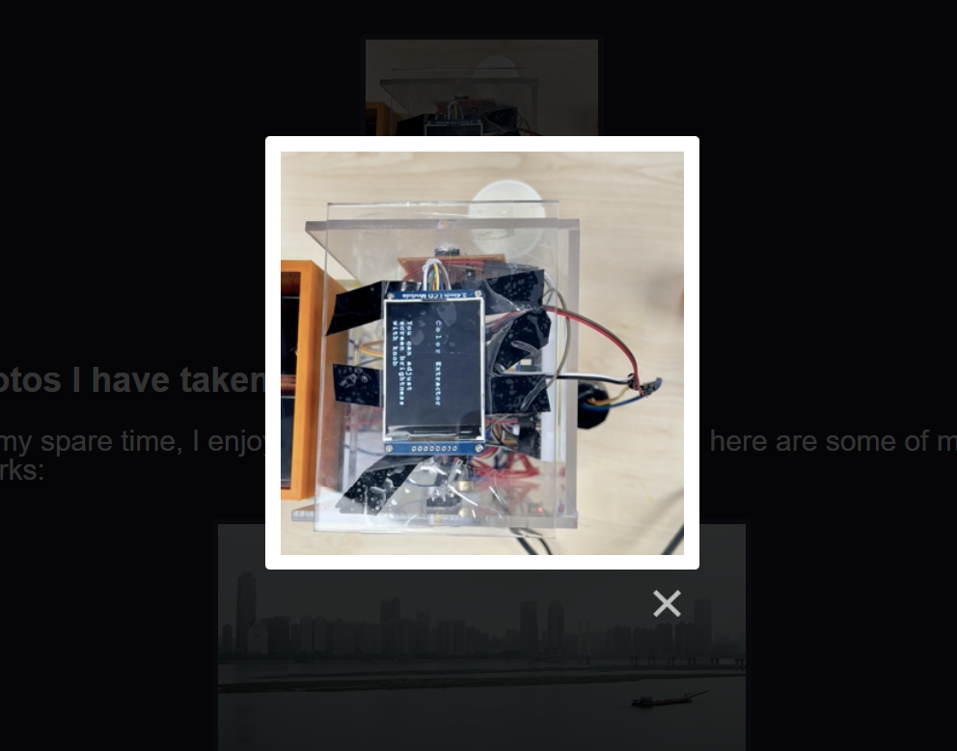

**13, Media Query for Tablet Layout**

**Using the browser of your choice, walk us through the different responsive design choices you made. Make sure to impress us. The changes should be drastic, obvious, and should improve the look/functionality of the site.**

**Mobile view:**

Less than 400px width:

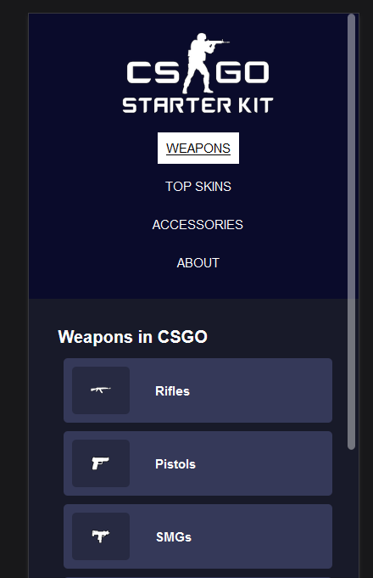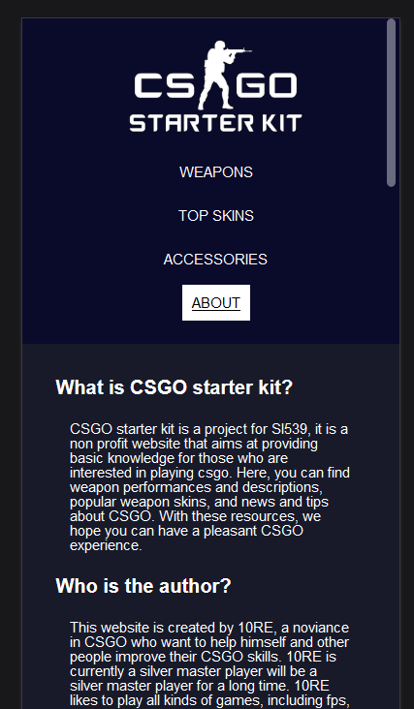

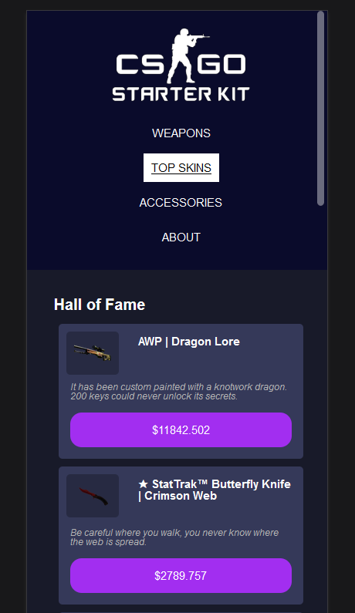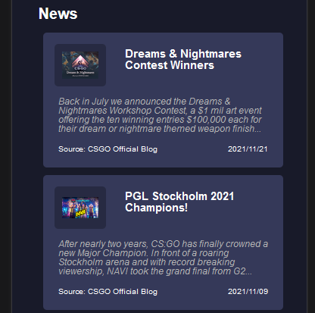

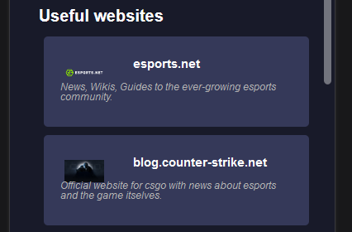

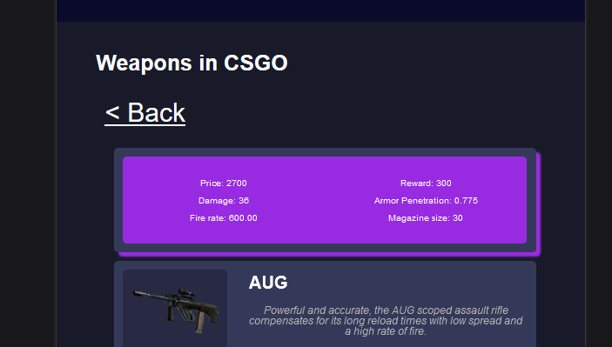

**Tablet view:**

Less than 700px width:

Font size enlarges. Description of the item and price button moved to occupy only the right column of the item panel. Images in both panels and about page enlarges.

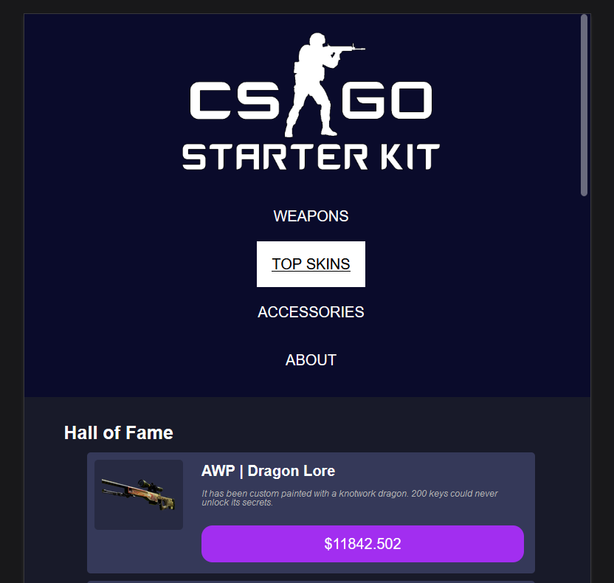

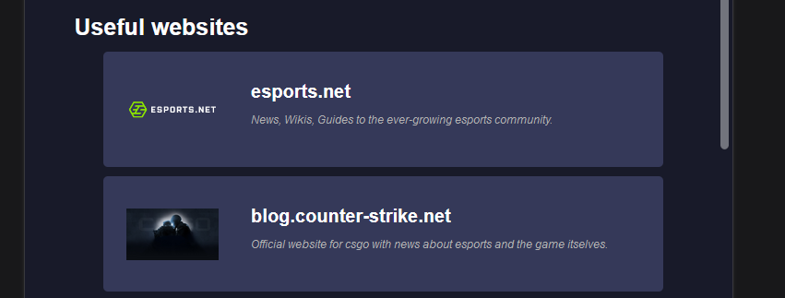



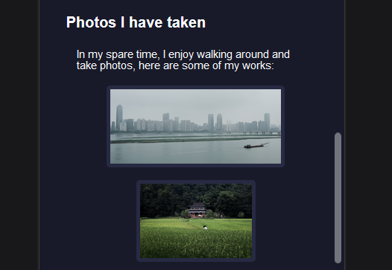

Less than 1010px width:

Font size enlarges. Navigation bar becomes a horizontal layout. Flip card information layout turns from grid to flex.

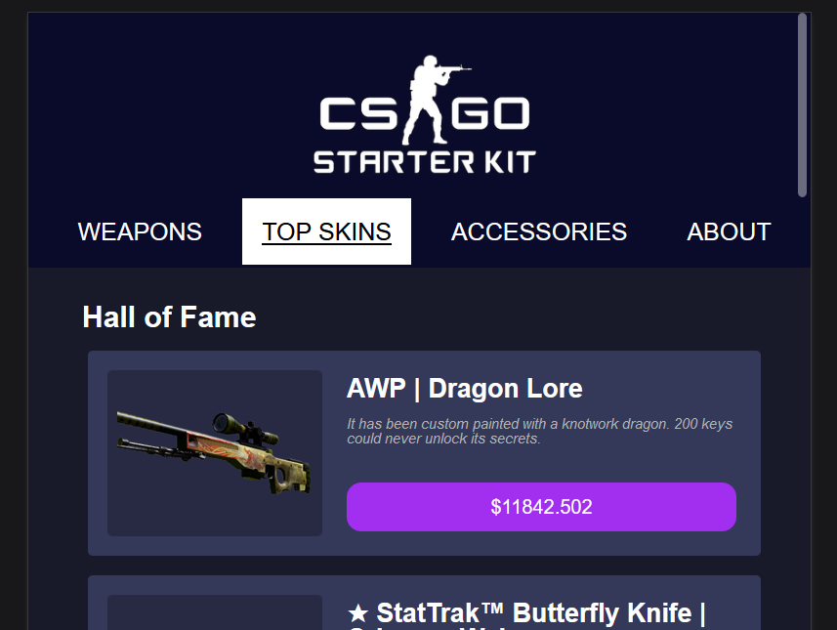

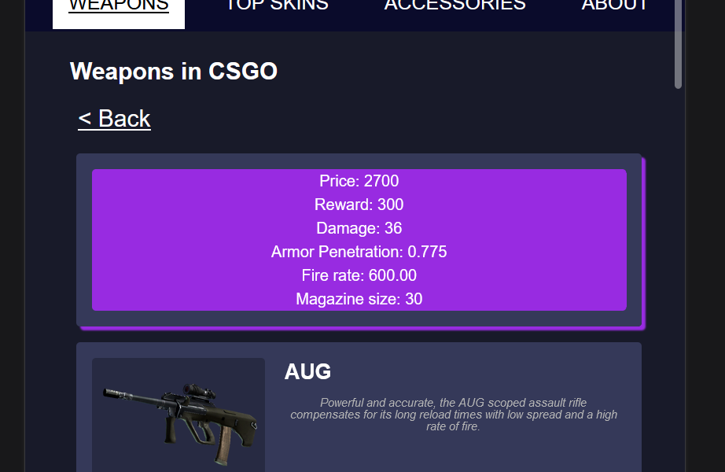

**14, Media Query For Desktop layout**

**Using the browser of your choice, walk us through the different responsive design choices you made. Make sure to impress us. The changes should be drastic, obvious, and should improve the look/functionality of the site.**

**Desktop view:**

Larger than 1010px width:

Font size enlarges. Image size enlarges. Navigation bar moves to the right of the website logo. The item container turns into a grid. Item panel layout turns to a column flex.

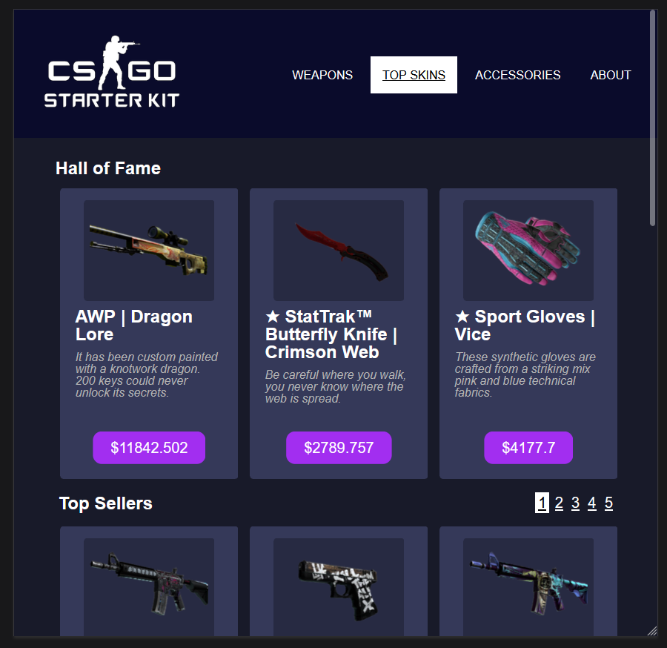

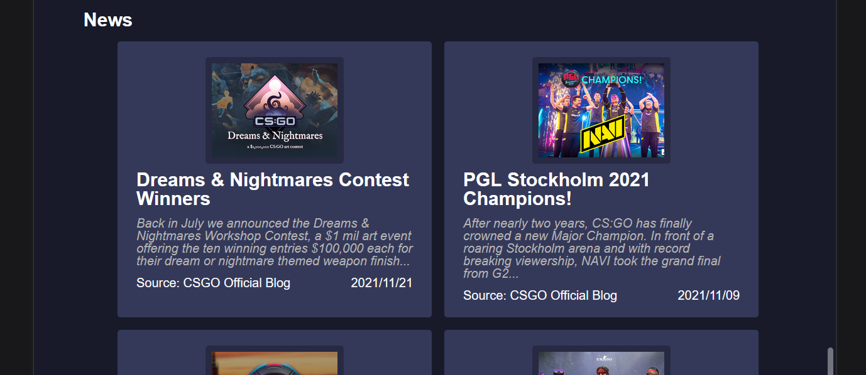

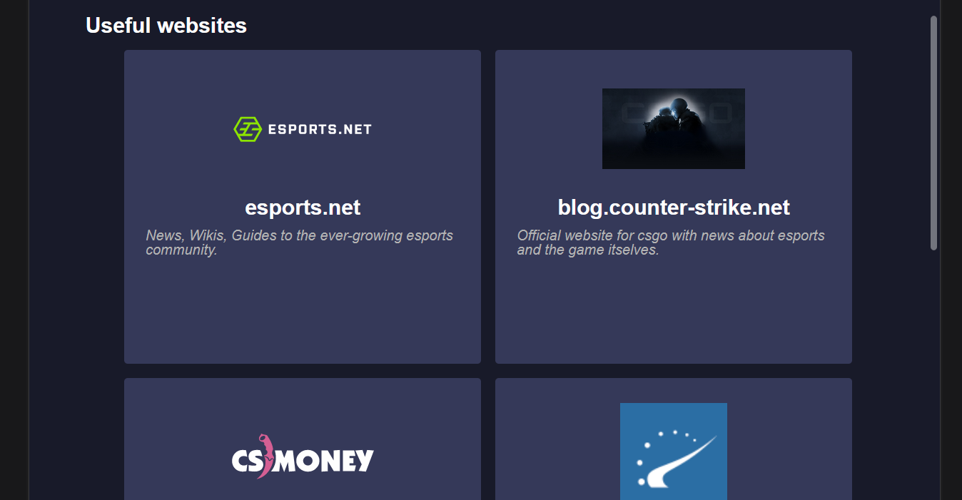

As the width of the screen increases, the grid column number increases.

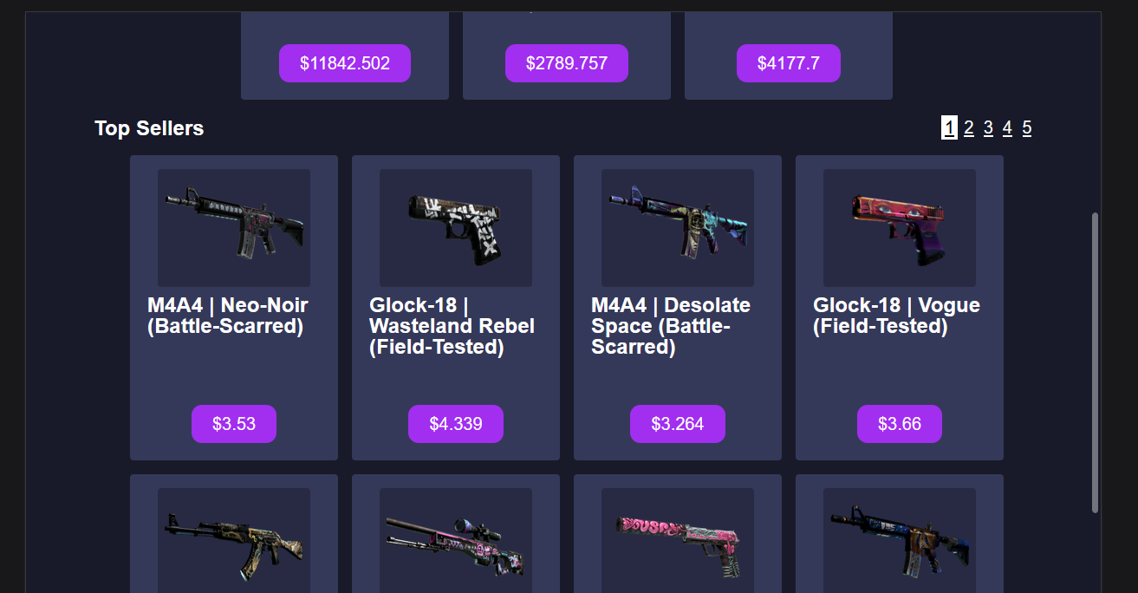

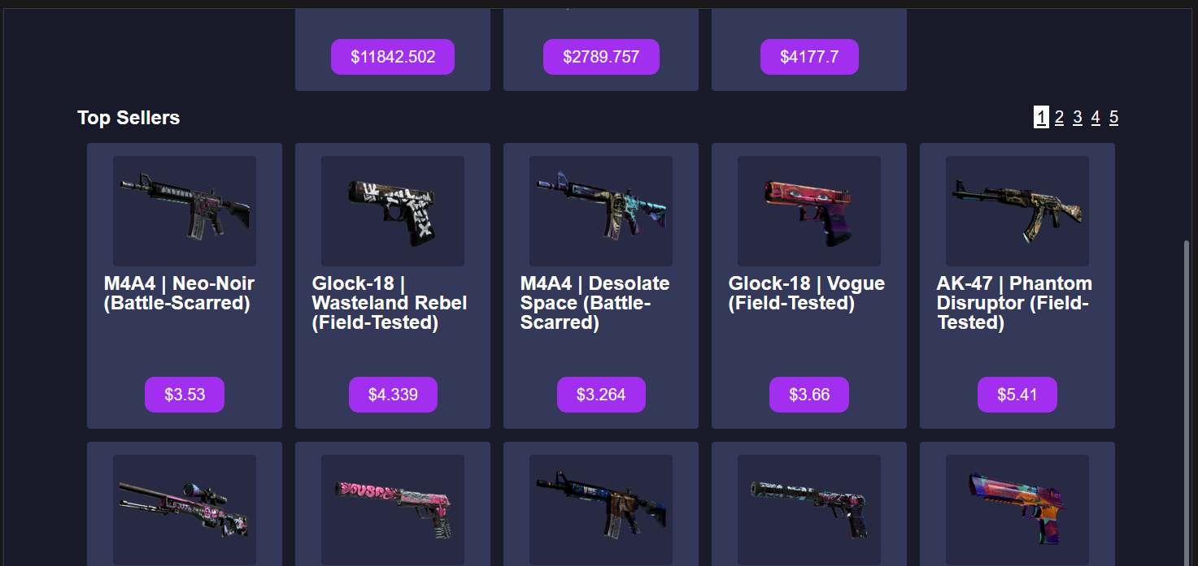

Larger than 1200px width:

Font size enlarges. The about page turns from plain html to grid.

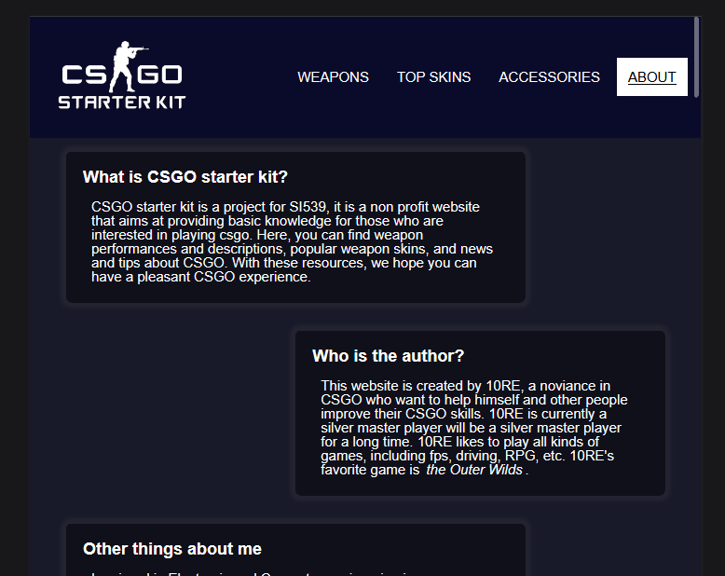

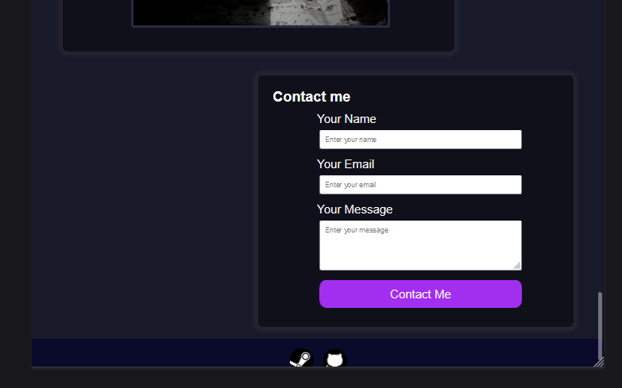

**15, Documentation/Demonstration - Validation**

**Validate all four pages on both aXe and Wave. Demo on your deployed page.**

No error on all four pages.

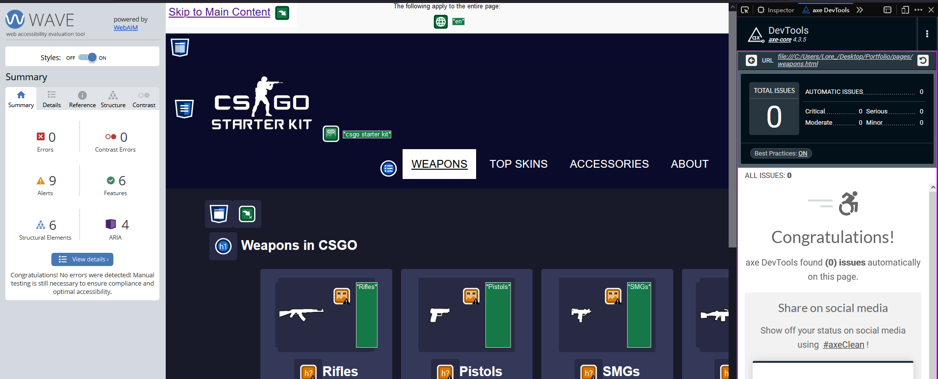

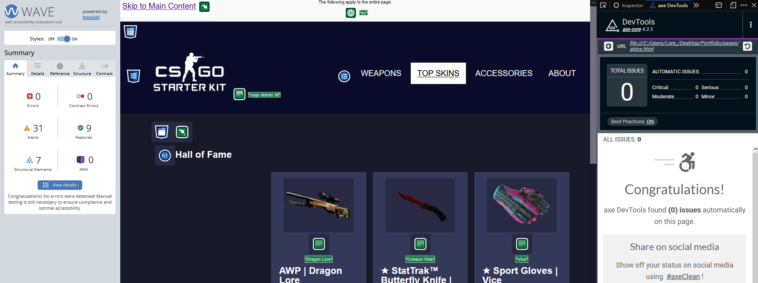

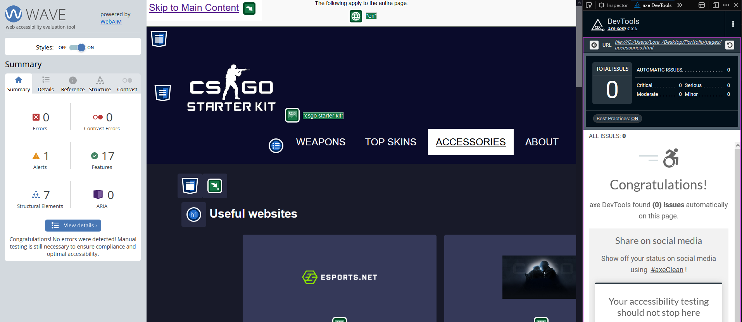

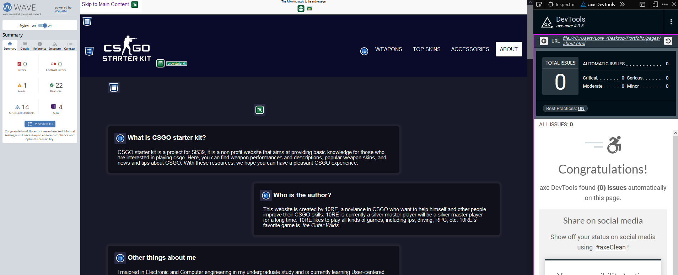

For inner weapon page, axe gives error:

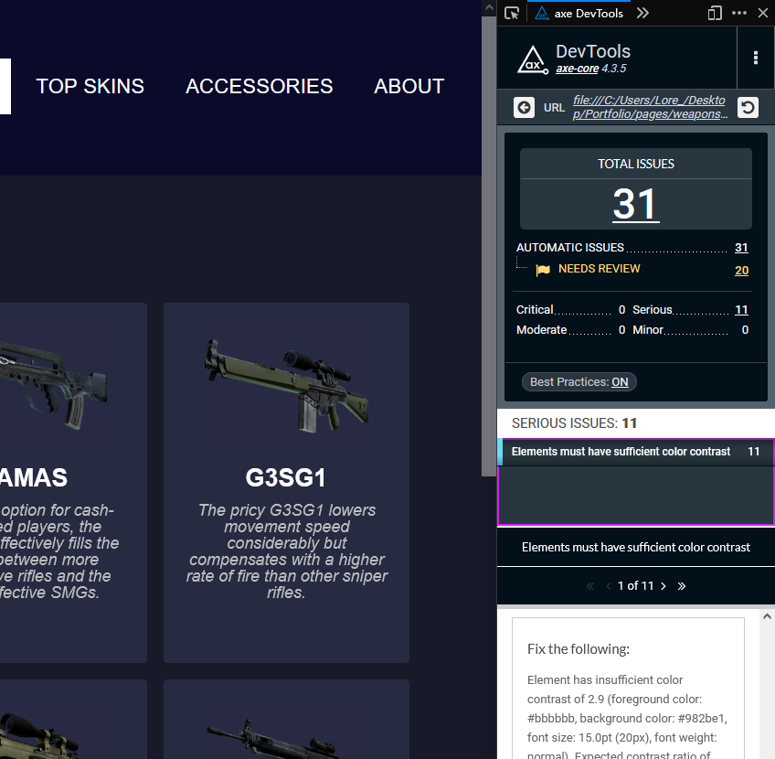

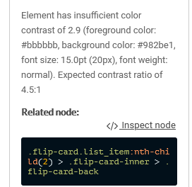

However, AXE mistakenly considers the background of the other side of the flip card to be the background for the front side of the card, the actual background here is #272b42, not #982be1.

**16, Documentation/Demonstration - Accessibility, diversity and inclusion**

**A summary of the steps you took to ensure that your site addresses accessibility, diversity and inclusion.**

For flip cards, users are allowed to use a keyboard tab to flip the card**.**

If users prefer reduced motion, the website will respond by removing the animation, including the skip button, the flip card, lightbox and parallax image.

Color contrast validated for all pages, with AXE and WAVE.

For users with color issues, an underline is indicated in the navigation bar to indicate the current page users are on.

Important images have alt values for screen reader.

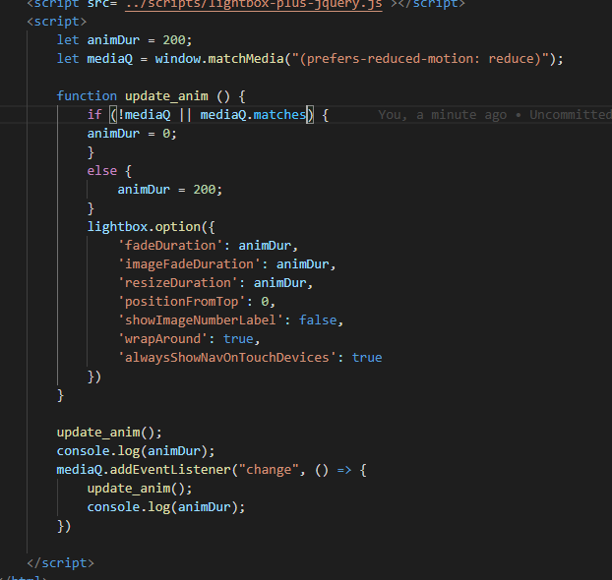

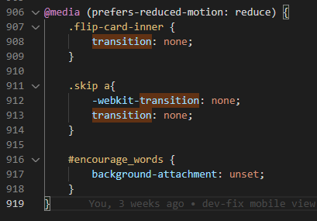

| **Criteria** | **Your Expected Score** |  |
| --- | --- | --- |
| Submit a (minimum four page) site. All of the pages must use a common header, footer, and navigation across all pages. Each page must have a unique title | /2.5 |  |
| The navigation must clearly display the current page within the nav element. As you visit each page, point out how the navigation bar changes to clearly indicate which page you are currently viewing. Don't forget, color alone should never be used to signify important information. | /2.5 |  |
| Each page should contain a main section that can be reached using a Jump to Content option with the first tab on the page. Main must be after the navigation. Make sure to check that "Skip To Content" works on EVERY page. | /2.5 |  |
| Grid - used effectively.  What elements use grid and which pages are these elements on? How did you use grid differently from the homework? | /10 |  |
| Flex - used effectively.  What elements use flex and which pages are these elements on? How did you use flex differently from the homework? | /10 |  |
| At least one CSS generated animation that is NOT part of the gallery. Does the animation stop when prefers-reduced motion is activated? | /2.5 |  |
| A working contact form. The form should be processed, not sent via email. | /2.5 |  |
| A parallax image | /2.5 |  |
| A keyboard accessible flip card using just CSS. Ensure that the flipcard works using a mouse AND the keyboard. Does any animation stop when prefers-reduced motion is activated? | /5 |  |
| Google Analytics on all four pages. We should be able to see multiple past visitors on each page. | /2.5 |  |
| Visually appealing What did you do to make your page particularly appealing? How did you come up with your color scheme? Tell us more about your font choices, image editing, etc. I am sure there are things that you did that we can't easily see. | /7.5 |  |
| Tell us about your Responsive Design. What is your tablet breakpoint and why did you pick that particular value for your first media query? What is changed in the layout? What is changed in the styling ? Were you careful to not duplicate unnecessary code? | /7.5 |  |
| Tell us about your Responsive Design. What is your desktop breakpoint and why did you pick that particular value for your second media query? What is changed in the layout? What is changed in the styling ? Were you careful to not duplicate unnecessary code? | /7.5 |  |
| Validation | /10 |  |
| Accessibility, diversity and inclusion. Include a summary of the steps you took to ensure that your site addresses accessibility, diversity and inclusion. | /7.5 |  |